**DAILY ONLINE ACTIVITIES SUMMARY**

|  |  |  |  |  |  |  |  |  |
| --- | --- | --- | --- | --- | --- | --- | --- | --- |
| **Date:** | **31-05-2020** | | | | | **Name:** | **Huda Sultana** | |
| **Sem & Sec** | **8 A** | | | | | **USN:** | **4AL16CS039** | |
| **Online Test Summary** | | | | | | | | |
| **Subject** | | **IOT** | | | | | | |
| **Max. Marks** | | **20** | | **Score** | | | **20** | |
| **Certification Course Summary** | | | | | | | | |
| **Course** | **Data and Computer Communication Network.** | | | | | | | |
| **Certificate Provider** | | | **RLJIT** | | **Duration** | | | **180 mins** |
| **Coding Challenges** | | | | | | | | |
| **Problem Statement:**   1. **C program to find the reverse a string using pointers.** | | | | | | | | |
| **Status: Solved** | | | | | | | | |
| **Uploaded the report in Github** | | | | | **Yes** | | | |
| **If yes Repository name** | | | | | **Hudasulltana/online_coding** | | | |
| **Uploaded the report in slack** | | | | | **Yes** | | | |

Online Test Details: (Attach the snapshot and briefly write the report for the same)

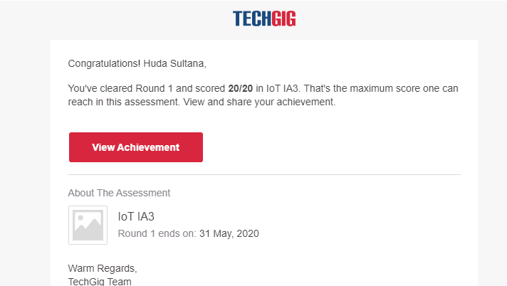

Certification Course Details: (Attach the snapshot and briefly write the report for the same)

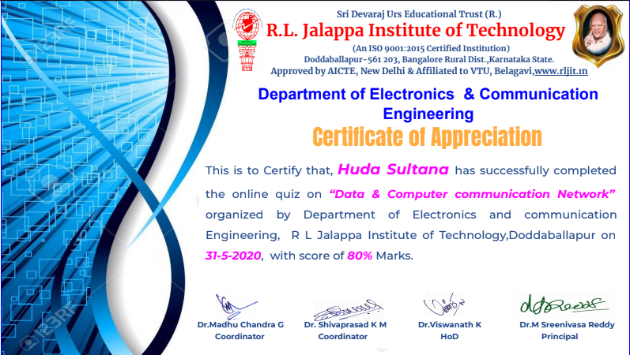

Coding Challenges Details: (Attach the snapshot and briefly write the report for the same)

**PROGRAM 1 .**

**// C program to find the reverse a string using pointers.**

**#include <stdio.h>**

**int main()**

**{**

**char str[100];**

**char rev[100];**

**char *sptr = str;**

**char *rptr = rev;**

**int i = -1;**

**printf("\n\nEnter a string: ");**

**scanf("%s", str);**

**while(*sptr)**

**{**

**sptr++;**

**i++;**

**}**

**while(i >= 0)**

**{**

**sptr--;**

**\*rptr = *sptr;**

**rptr++;**

**i--;**

**}**

**\*rptr = '\0';**

**rptr = rev;**

**while(*rptr)**

**{**

**\*sptr = *rptr;**

**sptr++;**

**rptr++;**

**}**

**printf("\n\nReverse of the string is: %s ", str);**

**return 0;**

**}**